Chapter 12. Transcendental Functions as Fractals
12.1 Introduction
In simple terms, these are functions like Sine, Cosine etc. most of the times we have been dealing with these functions only in the real space. What if the are considered in the imaginary space? They produce beautiful Fractals when they are explored as fractals in the imaginary space. If z=x+iy,
Cos(z) = cos(x)cosh(y)-isin(x)sinh(y)
Sin(z) = sin(x)cosh(y)+icos(x)sinh(y)
Cosh(z) = cosh(x)cos(y)+isinh(x)sin(y)
Sinh(z) = sinh(x)cos(y)+icosh(x)sin(y)
e^{iz} = e^{x}(cos(y)+isin(y))
We iterate equations with them on Mandelbrot or Julia like method to create Fractals.
12.2 Cosine Fractal Implementation
We iterate the equation z_{n+1} = cos(z_{n})+c
Workbook: Worksheets/Transcendental Functions/Unexpanded/Cosine Fractal 1024.
Fig 12.1 below shows the initial parameters used for the fractal
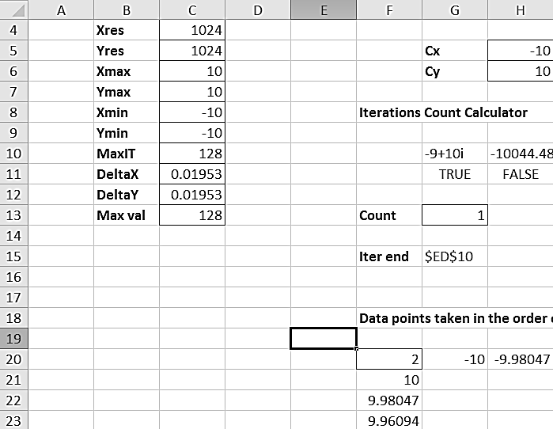
Fig 12.1 Initial Parameters of Cosine Fractal
This is a Mandelbrot type expansion of Cosine fractal. The formula in Cells G10 and H10 are the only changes compared to the previous ones.
G10 ---- =IMSUM(COMPLEX(COS(0)*COSH(0),-SIN(0)*SINH(0)),COMPLEX($H$5,$H$6))
H10 ---- =IMSUM(COMPLEX(COS(IMREAL(G$10))*COSH(IMAGINARY(G$10)),-SIN(IMREAL(G$10)) * SINH(IMAGINARY(G$10))),COMPLEX($H$5,$H$6))
Upon generating, you should get a fractal image like in Fig 12.2.
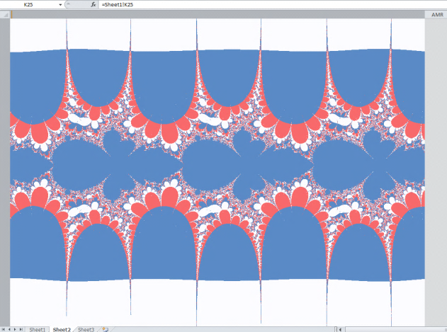
Fig 12.2 Cosine Fractal
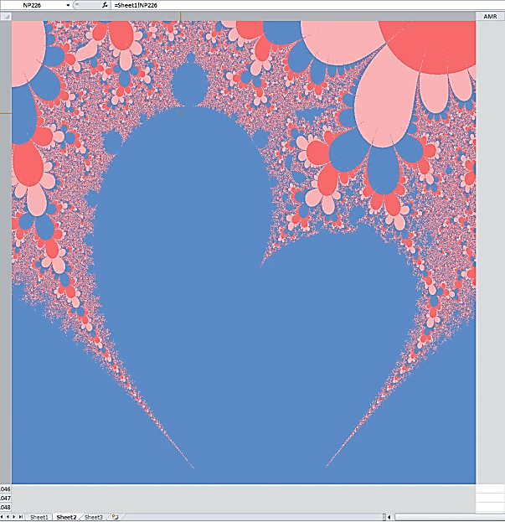
Fig 12.3 Cosine Fractal with a portion expanded
The above picture in Fig 12.3 is an expanded portion of a Cosine Fractal. We use the parameters as given below in Fig 12.4
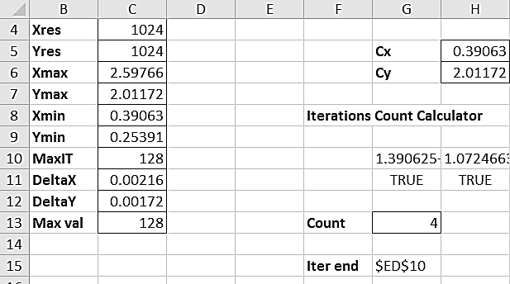
Fig 12.4 Initial Parameters for the Cosine Fractal Expansion
Cosine Fractal can also be expanded using Julia Method.
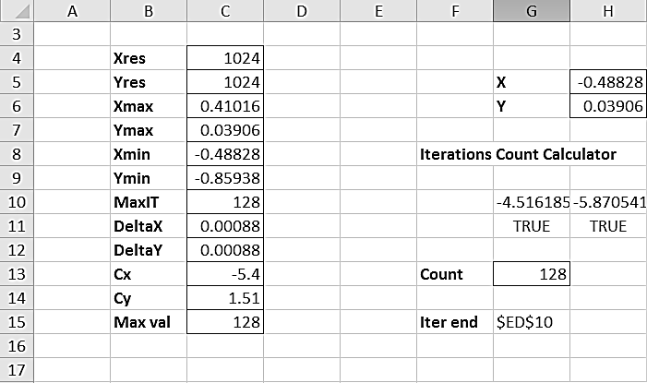
Fig 12.5 Initial Parameters for Expanded Cosine Fractal in Julia method
Notice the use of Cx and Cy as permanent constants
Formula in
G10 ---- =IMSUM(COMPLEX(COS($H$5)*COSH($H$6),-SIN($H$5)*SINH($H$6)),COMPLEX($C$13,$C$14))
H10 ---- =IMSUM(COMPLEX(COS(IMREAL(G10))*COSH(IMAGINARY(G10)),-SIN(IMREAL(G10))*SINH(IMAGINARY(G10))),COMPLEX($C$13,$C$14))
The expanded figure looks like Fig 12.6
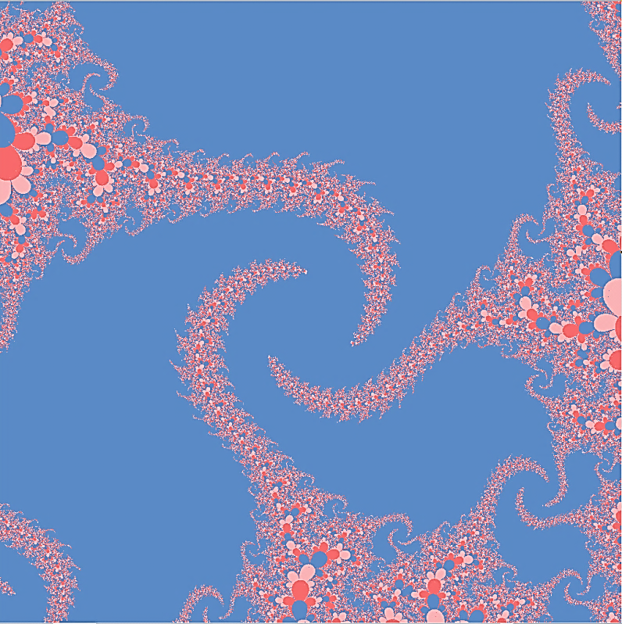
Fig 12.6 Expanded Cosine Fractal in Julia Method

12.3 Sine Fractal Implementation
We iterate the equation z_{n+1} = sin(z_{n})+c
Workbook: Worksheets/Transcendental Functions/Unexpanded/Sine Fractal 1024.
The figure below - Fig 12.7 - shows the initial parameters used for the fractal
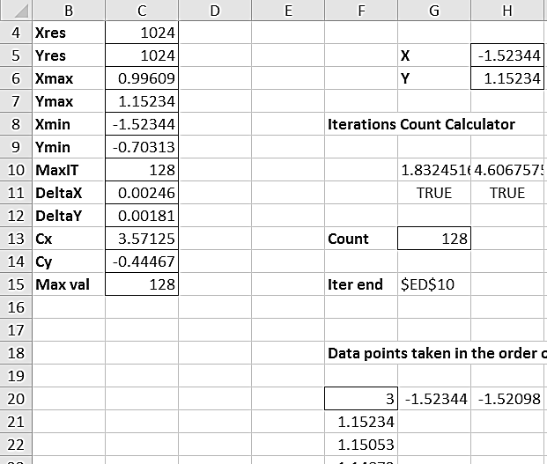
Fig 12.7 Initial Parameters for Sine Fractal
This is a Mandelbrot type expansion of Sine fractal. The formula in Cells G10 and H10 are the only changes compared to the previous ones.
G10 ---- =IMSUM(COMPLEX(SIN($H$5)*COSH($H$6),COS($H$5)*SINH($H$6)),COMPLEX($C$13,$C$14))
H10 ---- =IMSUM(COMPLEX(SIN(IMREAL(G10))*COSH(IMAGINARY(G10)),COS(IMREAL(G10))*SINH(IMAGINARY(G10))),COMPLEX($C$13,$C$14))
Upon generating, you should get a fractal image like Fig 12.8.
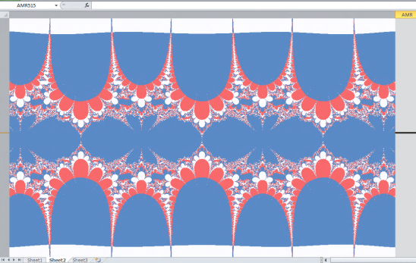
Fig 12.8 Sine Fractal
An expanded Sine Julia like fractal looks like Fig 12.10 with the below shown parameters
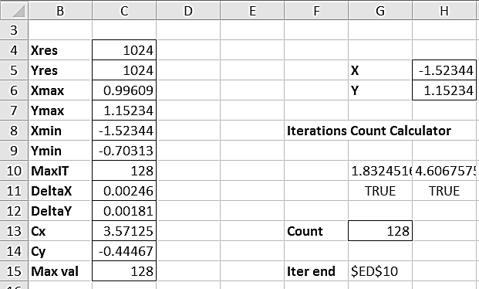
Fig 12.9 Initial parameters for Expanded Sine fractal (Julia Method)
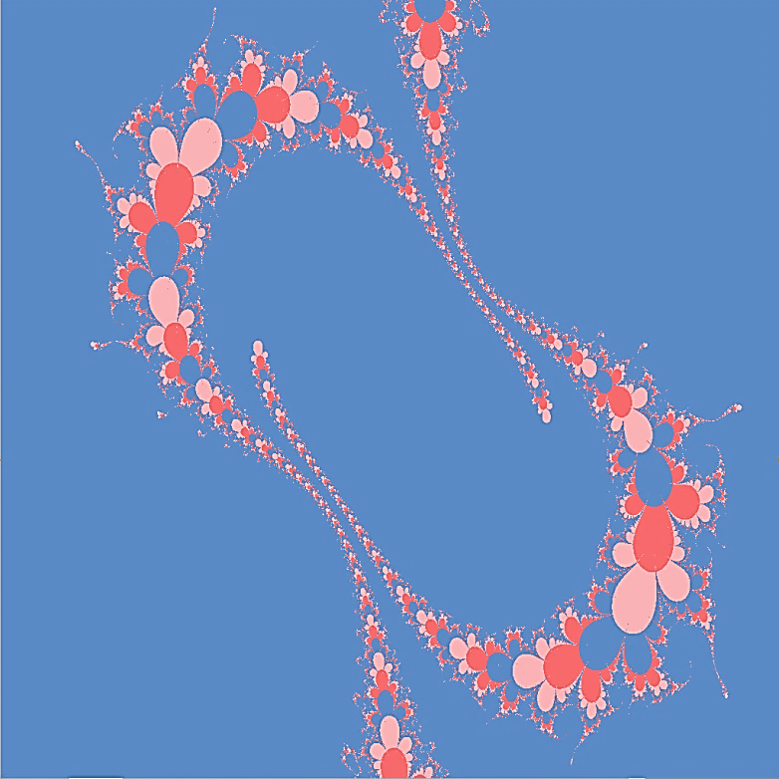
Fig 12.10 Sine Fractals Expanded in Julia method

12.4 Hyperbolic Cosine Fractal Implementation
We iterate the equation
z_{n+1} = cosh(z_{n})+c
Workbook: Worksheets/Transcendental Functions/Unexpanded/Hyperbolic Cosine Fractal 1024.
The figure below shows the initial parameters used for the fractal
Fig 12.11 Initial Parameters for Cosh Fractal
A Mandelbrot type expansion looks like Fig 12.12.

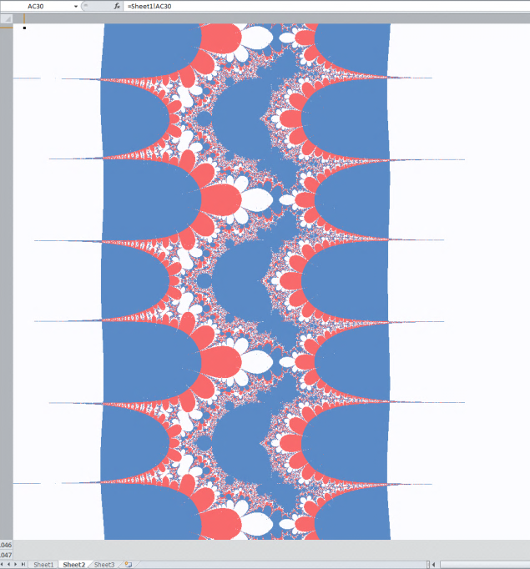
Fig 12.12 Cosh Fractal

12.5 Hyperbolic Sine Fractal Implementation
We iterate the equation
z_{n+1} = sinh(z_{n})+c
Workbook: Worksheets/Transcendental Functions/Unexpanded/Hyperbolic Sine Fractal 1024.
The figure below shows the initial parameters used for the fractal
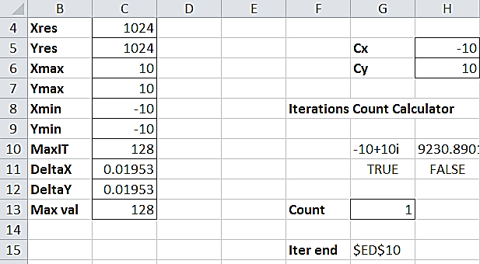
Fig 12.13 Initial Parameters for Sinh fractal
The Mandelbrot expansion of Sinh looks like Fig 12.14.
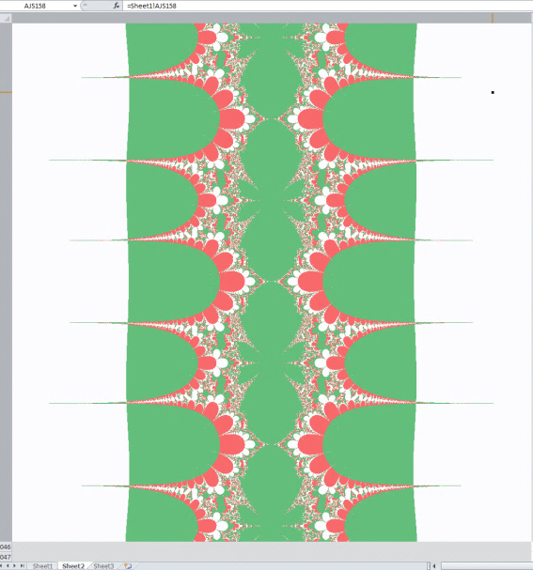
Fig 12.14 Sinh fractal
A Julia type expansion with the following parameters will look like Fig 12.16.
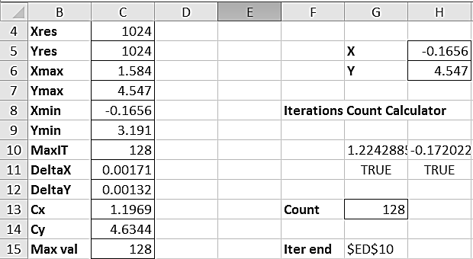
Fig 12.15 Initial parameters for expanded Sinh fractals – Julia method

Fig 12.16 Sinh expanded – Julia method

12.6 Exponential Fractal
We iterate the equation z_{n+1} = c exp(z_{n})
Workbook: Worksheets/Transcendental Functions/Unexpanded/Exponential Fractal 1024.

Here if we add c as a multiplyer because the other case creates uninteresting fractals. The fractal looks like Fig 12.18
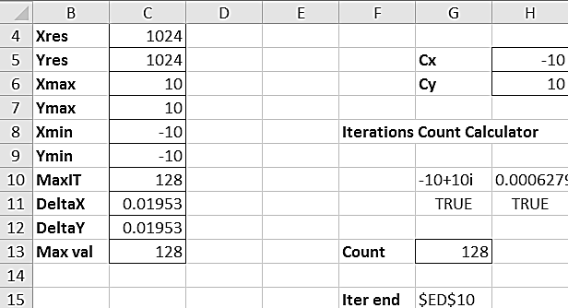
Fig 12.17 Initial parameters for exponential fractal


Fig 12.18 Exponential fractal
An expanded Exponential Fractal with the following parameters looks like Fig 12.20
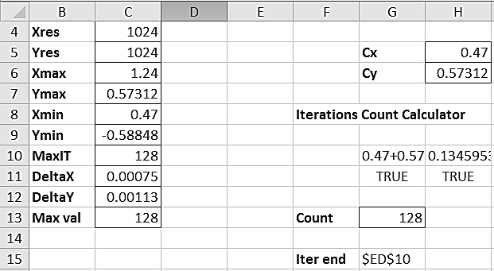
Fig 12.19 Initial parameters for expanded exponential fractal


Fig 12.20 Expanded Exponential fractal
You can create even more beautiful fractals with these simple functions by experimenting with various C vales and screen coordinates.

